9/11: The Shocking Truth Laid Bare
Lasha Darkmoon September 7, 2014 Articles
This article consists of key 9/11 quotations arranged in the form of a 6500-word dramatic collage so as to give the impression of a live “debate” — an imaginary debate in which the shocking Truth is finally laid bare.

WHO DID 9/11?
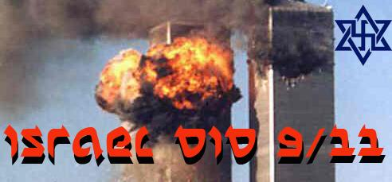

1. Introduction
LASHA DARKMOON: I’d like to start by saying that every statement you read here is a 100 percent authentic quote. Nothing has been fabricated. You can check out every word and phrase on the internet. The only bits you won’t find already published are my own interconnecting comments. As the editor of the article, I have allowed myself the privilege of taking part in this imaginary “debate”.
If the overall effect is at times surrealistic, this is intentional. The entire 9/11 debate, after all, is an exercise in surrealism replete with the most bizarre Alice in Wonderland logic. The mere fact that the chief suspects of the 9/11 crime have been allowed to investigate themselves makes this only too clear.
The aim of the debate is to pose and answer the question: Who did 9/11? My own conclusion has already been stated elsewhere:
“Israel is the rogue state that is arguably responsible for the greatest mass murder in history: the catastrophe of 9-11. If scientific evidence and forensic logic are anything to go on, Israel has to be suspect number one here, given its unbroken record of terrorism and its endless breaches of international law. Any country that can orchestrate such a spectacular crime and get away with it—while somehow managing to pin the blame on nineteen Arabs with box cutters—is clearly a force to be reckoned with.”
Finally, I wish to apologize in advance for any offense given by this article. No offense is intended. My aim is simply to provide the reader with a wide variety of 9/11 quotes in a dramatic format that will, hopefully, have maximum emotional impact.

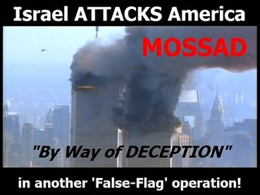“Wildcard. Ruthless and cunning. Has capability to target US forces and make it look like a Palestinian/Arab act.”
— Comment about Mossad in a report issued by the US Army School of Advanced Military Studies, quoted in the Washington Times on September 10, 2001, the day before 9/11.
DR ALAN SABROSKY (former director of studies at the US Army War College): What we need to stand up and say is that not only did they, the Israelis, attack the USS Liberty – they did 9/11 also. They did it!
I have had long conversations over the past two weeks with contacts at the Army War College, at the Headquarters Marine Corps, and I have made it absolutely clear in both cases that it is 100 percent certain that 9/11 was a Mossad operation. Period. The Zionists are playing this as an all-or-nothing exercise. Because if they lose this one, if the American people ever realize what really happened, they’re done!
LASHA DARKMOON: Mr President, I can see you are not very happy with this introduction. Would you like to make the opening statement for the defense?
BARACK OBAMA (lamely) : I’m aware that there’s still some who would question or even justify the events of 9/11. But let us be clear: Al Qaeda killed nearly 3,000 people on that day. The victims were innocent men, women and children from America and many other nations who had done nothing to harm anybody. And yet al-Qaeda chose to ruthlessly murder these people, claimed credit for the attack, and even now states their determination to kill on a massive scale. They have affiliates in many countries and are trying to expand their reach. These are not opinions to be debated; these are facts.
TONY BLAIR: There have been the most terrible, shocking events taking place in the United States of America within the last hour or so, including two hi-jacked planes being flown deliberately into the World Trade Centre. I am afraid we can only imagine the terror and the carnage there and the many, many innocent people who will have lost their lives…. For the moment, let me say this: Saddam Hussein’s regime is despicable, he is developing weapons of mass destruction, and we cannot leave him doing so unchecked….
HUGO CHAVEZ: Don’t be shameless, Mr Blair! Don’t be immoral, Mr. Blair! You are one of those who have no morals. You are an imperialist pawn who attempts to curry favor with Bush-Hitler, the number one mass murderer and assassin there is on the planet! Go straight to hell, Mr. Blair!
FRANCESCO COSSIGA (former Prime Minister of Italy): All the intelligence services of America and Europe know well that the disastrous 9/11 attack was planned and realized by the CIA and Mossad, with the help of the Zionist world, in order to pin the blame on the Arab Countries and persuade the Western powers to intervene in Iraq and Afghanistan.
ABRAHAM FOXMAN (furious) : These hateful conspiracy theories rationalize and fuel global anti-Semitism! . . . Perhaps the most notorious conspiracy theory of modern times suggested that 4,000 Jews were pre-emptively warned to stay away from the World Trade Center the day of the 9/11 terrorist attacks, a myth that quickly morphed into the Big Lie that Israel and Jews were responsible for 9/11.
BRITISH HISTORIAN DAVID IRVING (sarcastically) : We are happy to report that the 4,000 figure dwindled eventually to three (not three thousand, but three), then two, then one: the unfortunate Daniel Lewin!
LASHA DARKMOON (explaining) : On September 12, the Jerusalem Post reported that the Israeli embassy in America was bombarded on 9/11 with calls from 4,000 worried Israeli families. This was a preemptive move. It was a sly attempt to deceive the public into thinking the Israelis were victims of 9/11 like everyone else. In fact, they were not.
Nearly 500 foreign nationals from over 80 different nations had been killed in the World Trade Center. A large number of Israelis had worked in the buildings and so a proportionately large number of Israelis could be expected to have died there. To give the impression that this was the case, President Bush, primed by his Jewish minders, announced soon after the tragedy that 130 Israelis had died in the towers. To his subsequent embarrassment, 129 of these Israelis were found to be alive and well. The number of Israelis who died in the Twin Towers turned out to be ridiculously small, in defiance of the law of averages — only one man! And he was a chance visitor who happened to be passing by.
It appears that hundreds of Israelis who ordinarily worked in the buildings, or had business there every day, had either been forewarned to stay away, or, by sheer good luck, had been kept away by mysterious forces. In total, three Israelis died in the 9-11 attack: two on the ‘hijacked’ planes and one in the Twin Towers, a casual visitor. The rest had been warned to stay away by the Odigo messaging service.
Coincidentally, Odigo had a branch office only two blocks away from the World Trade Center. Even more coincidentally, Odigo’s headquarters were located in Herzliya, Israel, a town just north of Tel Aviv where — wonder of wonders! — Mossad is also headquartered.
ALEX DIAMANDIS (Odigo’s vice president, admitting Israeli foreknowledge): The messages said something big was going to happen in a certain amount of time, and it did — almost to the minute!
LASHA DARKMOON: Well, there you have it! A frank admission that Odigo, an Israeli company located a mere stone’s throw away from Mossad in a little town near Tel Aviv , knew that 9/11 was going to happen and warned Jews to stay away! There were many lucky Jews that morning. Consider this. An Israeli government run company called Zim Israel Navigational, the 9th largest shipping company in the world, had 200 employees working in the North tower. One week before 9/11, Zim moved out of its World Trade Center offices with its 200 workers. And they were so keen to get out quickly that they were ready to pay a $50,000 fine for breaking their lease!
Then there was ‘Lucky’ Larry Silverstein, owner of the WTC buildings. He too had a miraculous escape. Every morning, as faithful as clockwork, Lucky Larry would enjoy breakfast at the Windows on the World restaurant atop the North Tower. His daughter Lisa would show up for breakfast too — a regular feature. On the morning of 9/11, both father and daughter (smilingly pictured here) found excuses for staying away. Lucky Larry discovered he had a dermatologist’s appointment. Daughter Lisa was caught up in a convenient traffic jam.
Lucky Larry had a son. He too was expected in the building that morning. Like his sister Lisa, he too had the extraordinary good luck to be caught in a traffic jam — in a different part of the city.
Truly, God was smiling on his Chosen people that morning.
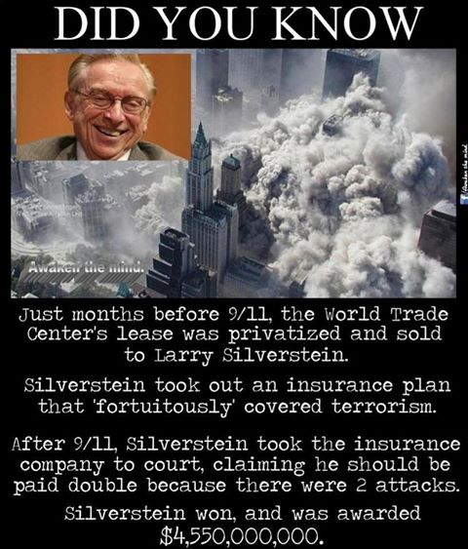

2. They lie about everything
LASHA DARKMOON: How can so many Americans still believe in the outrageous lie that Al Qaeda did 9/11 when there are so many Jewish fingerprints all over this crime?
SEYMOUR HERSH: We lie about everything.
FRANCESCO COSSIGA (former Prime Minister of Italy) : I have always said that the intelligence agencies of the leading nations of the world are certainly very well aware that the official version is a fraud. The largest media networks are also aware of the 9-11 hoax, primarily because of their fundamental role in perpetrating this fraud on the public. The people are always the last to know the truth.
ABRAHAM FOXMAN (angrily): It is incumbent upon all good people who reject hateful conspiracy theories and anti-Semitism to stand up and speak out! — so that these unacceptable views remain marginalized and relegated to the far fringes of society and the darkest corners of cyberspace!
KEVIN BARRETT (ignoring Foxman) : Recently, Seymour Hersh, America’s top mainstream investigative reporter, broke the news that the US government’s claim to have killed Osama Bin Laden on May 2nd, 2011 was a big lie. “There’s not one word of truth in it,” he said. Hersh went on to harshly criticize his long-time employer, the New York Times, and other big media outlets. He said all big US media outlets should be shut down for lying to the American people.
SEYMOUR HERSH : Lying has become the staple.
KEVIN BARRETT: Other mainstream journalists agree that the US government’s story of Osama Bin Laden and 9/11 is a big lie. Sherwood Ross, an award-winning journalist who has worked for the City News Bureau of Chicago, the Chicago Daily News, and for Reuters and other wire services, told me this in a recent radio interview.
SHERWOOD ROSS: It’s very doubtful that Muslims were behind 9/11. I don’t think 9/11 was an Arab conspiracy. I think it’s an American conspiracy to overthrow the government of the United States and install what is becoming a police state.
KEVIN BARRETT: Ross has explained that American journalists are no longer free to expose even the most outrageous falsehoods.
SHERWOOD ROSS: You don’t see any serious questioning by the mainstream media. I thought one of the tip-offs that it was a put-up job was when a cameraman from a little weekly in Pennsylvania went to the site where this airliner had supposedly crashed on 9/11. And he said, “I didn’t see any airliner. I saw a hole in the ground. I didn’t see any bodies. I didn’t see any luggage.”There was no wreckage! Reporters who worked in the Press Room at the Pentagon went out there on the lawn, and they couldn’t see any airliner!
THIERRY MEYSSAN: (famous French author) : How does a plane 125 ft. wide and 155 ft. long fit into a hole which is only 60 ft. across?
KEVIN BARRETT: I asked Ross whether he is allowed to express such views in his [mainstream] articles.
SHERWOOD ROSS: Absolutely not! You won’t see me quoted nowadays by the Associated Press!
KEVIN BARRETT: Another leading American journalist, Paul Craig Roberts, has also been banned from US mainstream media for telling the truth about 9/11.
PAUL CRAIG ROBERTS (grimly) : Now seen universally as a lawless warmonger and a nuisance, Washington’s soft power has been squandered. With its influence on the wane, Washington has become more of a bully. In response, the rest of the world is isolating Washington.
KEVIN BARRETT: Dr. Roberts served as Assistant Secretary of the Treasury, won the French Legion of Honor and other awards for his contributions to economics, and has been a regular columnist for the Wall Street Journal,Business Week, and other mainstream publications. But since he spoke out about the controlled demolitions of the three World Trade Center skyscrapers on 9/11, Paul Craig Roberts has been put on the mainstream media’s no-publish list.
PAUL CRAIG ROBERTS: One of the worst things that ever happened to America was when President Clinton allowed five companies to concentrate [= buy up] the American media. The so-called mainstream media is no longer the media. It doesn’t tell you anything. It’s a propaganda ministry—the Ministry of Propaganda.
KEVIN BARRETT: Rather than writing for the mainstream media, Paul Craig Roberts is now exposing the fake killing of Osama Bin Laden.
PAUL CRAIG ROBERTS: The neoconservatives who advocate America’s hegemony over the world called for “a new Pearl Harbor” that would allow them to launch wars of conquest. No evidence exists that supports the government’s 9/11 story. It is unnecessary for me to report the voluminous evidence that conclusively proves that the official story is a lie! You can read it for yourself. It is available online. You can read what the architects and engineers for 9/11 truth have to say. You can read the scientists’ reports.
LASHA DARKMOON: More than 200 senior military, intelligence, and law enforcement officials, including two generals, have now questioned the 9-11 Commission’s report. They have been joined by over 1500 top architects and engineers, 250 pilots and aviation experts, 400 university professors, and 250 survivors and their families.
KEVIN BARRETT: Don’t bother reading the mainstream media! As Seymour Hersh, Sherwood Ross, Paul Craig Roberts, and a rapidly growing number of ordinary Americans realize, the mainstream media’s motto is now: “We lie about everything.”
OSAMA BIN LADEN: As a Muslim, I do my best to avoid telling a lie. I had no knowledge of these attacks.
PROF. DAVID RAY GRIFFIN (author of eleven books on 9-11) : All the proffered evidence that America was attacked by Muslims on 9-11 appears to have been fabricated.
LASHA DARKMOON: It’s hard to see how Muslim hijackers could have been involved, given that no CCTV pictures exist of the hijackers anywhere in the airports. Moreover, there are no Arab names on any flight lists. No boarding staff were prepared to testify to having seen any Arab-looking persons boarding the planes. Above all, there’s not a single post-mortem indicating any Arab dead bodies at the scene of the crime. On the other hand, the passport of one of the alleged terrorists, Satam Al Suqami, apparently came fluttering down to Ground Zero where the FBI found it intact. Amazing, isn’t it?
DAVID RAY GRIFFIN: The FBI claimed that, while searching the streets after the destruction of the World Trade Center, they discovered the passport of Satam al-Suqami, one of the hijackers on American Flight 11. For this to be true, the passport would have had to survive the collapse of the North Tower, which evidently pulverized almost everything in the building into fine particles of dust — except the steel and al-Suqami’s passport. This claim is too absurd to pass the giggle test.
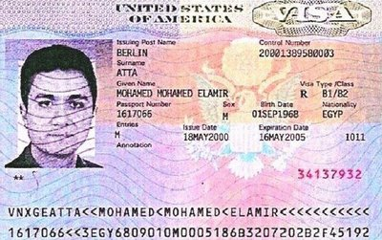The passport of alleged Al-Qaeda mastermind Mohammed Atta was miraculously found intact among the ashes of the Twin Towers.
PAUL CRAIG ROBERTS: How could a tiny undamaged passport be found in the rubble of two skyscrapers, each more than 100 stories tall, when bodies, office furniture and computers could not be found?
LASHA DARKMOON: Nothing that could have embarrassed the US government survived the explosions. Even the “indestructible” black boxes containing key flight information had been complete vaporized, contrary to the laws of physics. Even more miraculously and conveniently for the US government, two charred passports of alleged Al Qaeda terrorists, one of them ringleader Mohammed Atta (pictured), had been found intact in the ruins — almost as if someone had placed them there on purpose to be found. (See here)
CHRISTOPHER BOLLYN: What many people don’t understand about 9-11 is that there was no proper criminal investigation into 9/11. Although the World Trade Center was the scene of the greatest mass murder in U.S. history, the evidence from the crime scene, such as the structural steel, was treated like scrap; cut up into small pieces, mixed with other scrap metal, and shipped to China to be melted down. The public was given an utterly false story and incited to wage war in Afghanistan while the crucial evidence was being destroyed in two junkyards in New Jersey.
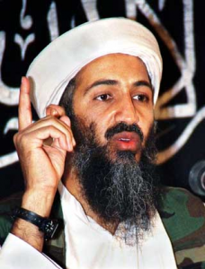 “I had no knowledge of these attacks!”
OSAMA BIN LADEN (pictured) : I had no knowledge of these attacks!
CHRISTOPHER BOLLYN: The FBI investigation of the events of 9-11 was being managed by Michael Chertoff, the Assistant Attorney General who was the US official who was supposed to collect the evidence, find the guilty parties, and prosecute them. Under Chertoff, however, an Israeli-American dual national, there was no 9-11 investigation and no prosecution.
In the end there was not a single trial for any of the families who lost loved ones on 9-11. The US District Judge who oversaw the 9-11 litigation was Alvin K. Hellerstein, a dedicated Zionist in New York whose son lives in an illegal Israeli settlement on the occupied West Bank.
If a crime like 9-11 is not properly investigated and prosecuted, you can be sure there is something to hide.
BIOLOGIST RICHARD DAWKINS (fatuously): Bin Laden has won! (After a jar of honey belonging to him was confiscated by airport security).
OSAMA BIN LADEN: What is this? Is it not that there exists a government within the government in the United Sates? That secret government must be asked as to who carried out the attacks. I have already said that we are not hostile to the United States. We are against the US Government system, which makes other nations slaves of the United States.
This system is totally in control of the American Jews, whose first priority is Israel, not the United States. It is clear that the American people are themselves the slaves of the Jews and are forced to live according to the principles and laws laid down by the Jews.

3. They kill people to silence them
KEVIN BARRETT: One of the leading scientists challenging the US government’s version of 9/11, Dr. Crockett Grabbe, has gone on record charging 9/11 cover-up forces with a series of murders and attempted murders — including attempts on his own life.
LASHA DARKMOON: They’re now actually killing people to silence them?
KEVIN BARRETT: In a recent interview on my radio show, Dr. Grabbe, a physics professor with a Ph.D. from Cal Tech, described a series of attempts on his life that followed the publication of his 2011 book National Swindle of the World Trade Center.
DR CROCKETT GRABBE: I’m not just referring to the murders that occurred on 9/11, but also the unexplained murders of both 9/11 witnesses and truth-seekers: Michael Doran, David Graham, Bertha Champagne. The interesting thing is, Bertha Champagne and Nancy Hamilton both had unexplained deaths from automobiles running over them.
LASHA DARKMOON: I notice quite a few mysterious automobile accidents taking place nowadays. This seems to be the new way of disposing of government whistleblowers and high profile witnesses. I’m thinking here of the Franklin cover-up and the Gunderson case, both involving high-level witnesses to government involvement in pedophile crimes. These witnesses conveniently meet their deaths in car accidents—bumped off before they can get to court.
DR GRABBE: The thing that made me a believer is that when I published my first book in 2011, there were unexplained, strange attempts to hit me with an automobile. It was just unbelievable! I’m not a 9/11 witness or anything. I’m just a physicist showing that nothing supports the official version of 9/11.
LASHA DARKMOON: How did they try to kill you?
DR GRABBE: There were actually several cases. I’ll mention two from back in 2011. The first one was…one morning I went out for a walk on the street. And there was a pickup that went past me at very high speed…then quickly stopped and started backing up at high speed towards me. I felt he was trying to hit me with the vehicle, but I couldn’t be sure till later, when I was going out to get my mail in the evening.
LASHA DARKMOON: This guy tried to kill you twice on the same day?
DR CROCKETT GRABBE: When I opened my mailbox, I heard an engine start up and saw a car come around the curve very rapidly about a hundred to two hundred feet away from me. My mailbox was full of mail … if I’d gotten the mail out, that pick-up, the way it was traveling close to sixty miles per hour and coming straight at me, it would have hit me!
KEVIN BARRETT: Dr. Grabbe’s book, Anatomy of Mass Murders,discusses the suspicious deaths of nineteen 9/11 witnesses or truth-seekers: Barry Jennings, Beverly Eckart, Kenneth Johanneman, Christopher Landis, Paul Smith, Major General David Wherley, Salvatore Princiotta, Deborah Palfrey, Barbara Olson, Michael H Doran, David Graham, Bertha Champagne, Nancy Hamilton, Suzanne Jovin, Perry and Beth Ann Kucinich (Rep. Dennis Kucinich siblings), David Kelly, Presanna Kalahasthi, and Senator Paul Wellstone.
SENATOR WELLSTONE AND HIS FAMILY
The senator asked too many awkward questions about 9/11. Soon he was dead, along with his wife and daughter, in a mysterious plane crash…
LASHA DARKMOON: Senator Paul Wellstone (pictured), now that’s an interesting case. The Senator was a 9/11 Truther who had said, “There are so many things going on in relation to 9/11 that just don’t make sense.”
Inflammatory comments like that, coming from a US senator, are clearly incompatible with longevity. Soon after he said that the Senator was dead, in a plane crash: along with his wife, his daughter, three staff members and two professionally trained pilots.
The investigation of this mysterious multiple death was a farce, just as the investigation of what really happened on 9/11 was perhaps the ultimate farce — an “investigation” conducted by Israeli American citizen Michael Chertoff (pictured here with his Jewish accomplices) into a crime committed by Mossad in cahoots with American neoconservatives — most of them also Jewish.
The only plausible explanation for Senator Wellstone’s death is that he and his entourage were assassinated.
DR JIM FETZER: Seymour Hirsch disclosed recently that Vice President Cheney was running “an executive assassination ring” from his office in the White House, where Wellstone appears to have been one of his targets.
LASHA DARKMOON: Why has no one investigated Cheney?
KEVIN BARRETT: Despite all the murders, the truth continues to spread. As a huge billboard in Times Square trumpeted the “smoking gun of 9/11” — the collapse of World Trade Center Building 7 – Americans rose up this fall to stop the planned bombing of Syria. Why? They simply did not believe government and media claims about the al-Ghouta chemical attack. Americans have been dragged into wars by false-flag attacks and government lies too many times.
GEORGE W. BUSH (butting in angrily) : Either you are with us, or you are with the terrorists!
PAUL CRAIG ROBERTS: America is in the toilet, and the rest of the world knows it. But the neocons who rule in Washington and their Israeli ally are determined that Washington start yet more wars to create lebensraum for Israel.
SENATOR JOHN McCAIN (taking the high moral ground) : Blaming the US government for the events of 9/11 mars the memories of all those lost on that day! It shakes Americans’ faith in their government at a time when that faith is already near an all-time low! It traffics in ugly, unfounded accusations of extraordinary evil against fellow Americans!
IRANIAN EX-PRESIDENT MAHMOUD AHMADINEJAD (tactlessly) : The majority of the American people believe some segments within the US government orchestrated the 9/11 attack to reverse the declining US economy and its grips on the Middle East in order also to save the Zionist regime.
BARACK OBAMA: For him to make a statement like that is inexcusable!
ANN COULTER: We should invade their countries, kill their leaders and convert them all to Christianity!
AL GOLDSTEIN (Jewish pornographer) : Christ sucks!
SARAH SILVERMAN (Jewish comedienne, passing off hate speech as humor) :I hope the Jews did kill Christ! I’d fucking do it again — in a second!
KEVIN MACDONALD: The Jewish elite fears an America that takes Christianity seriously.
SARAH SILVERMAN (insulting the relatives of 9/11 victims) : 9/11 widows give the best hand jobs!
LASHA DARKMOON: Despicable rat!
T.S. ELIOT (intervening tactlessly) : The rats are underneath the piles! The Jew is underneath the lot!
LASHA DARKMOON: Watch out, Mr Eliot, or you’ll ruin your reputation!… Suffice to say it’s quite true that there were lots of Jews lurking around “underneath the piles”, so to speak, both on 9/11 and before. There were many Jews in the Bush administration. They had close ties to the Israeli government.
Every one of the following kingpins of the Bush administration was also an Israeli citizen: Paul Wolfowitz, Richard Perle, Douglas Feith, Michael Chertoff, George Tenet (real name Cohen), Elliot Abrams, Donald Kagan, Richard Haas, Kenneth Adelman, Edward Luttwak, Robert Satloff, David Frum, David Wurmser, Steve Goldsmith, Marc Grossman, Ari Fleisher.
EHUD BARAK: Let there be no illusions! This attack is an attack on everything that Western civilization holds dear! And we know who the attackers are!
CHRISTOPHER BOLLYN: Ehud Barak certainly knows “who the attackers are”. He sees the chief architect of 9-11 every time he looks in the mirror!
DONALD RUMSFELD: There are things we don’t know we don’t know.
GEORGE W. BUSH (pounding the table with his fist) : If you’re not with us, you’re against us!
BENJAMIN NETANYAHU (smirks) : We are benefiting from one thing, and that is the attack on the Twin Towers and Pentagon!
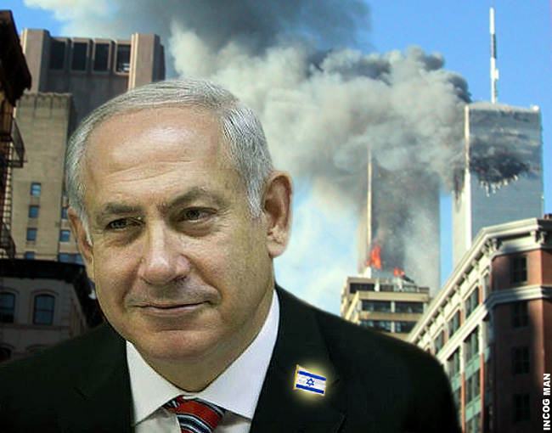

“9/11 was good for Israel!”

4. The 9/11 war criminals should be rounded up and executed
LASHA DARKMOON: The chief suspects of the 9/11 crime of the century have often been named. Here are the names of 39 individuals who should be taken into custody at once and closely questioned in a humane and civilized manner, preferably without waterboarding. Those with asterisks after their names are Jewish:
George W. Bush, Tony Blair, Benjamin Netanyahu*, Ehud Barak*, Shimon Peres*, Henry Kissinger*, George HW Bush, Dick Cheney, Donald Rumsfeld, Richard Perle*, Douglas Feith*, Dov Zakheim*, George Tenet (Cohen)*, Robert Mueller, John Ashcroft, Michael Chertoff*, Michael Mukasey*, Colin Powell, Condoleeza Rice, Richard Armitage, Philip Zelikow*, Ari Fleischer*, Karl Rove, Elliott Abrams*, Lewis “Scooter” Libby*, Jack Abramoff*, Rudolph Giuliani, Eliot Spitzer*, Richard Holbrooke, Michael Ledeen*, Larry Silverstein*, Frank Lowy*, David Rockefeller, Rupert Murdoch*, Maurice Greenberg*, Paul Bremer, William Kristol*,James Woolsey, Newt Gingrich.
Of these top 39 suspects, note that 22 (or more than half) are Jews, most of whom are also dual citizens with Israeli passports. If guilty of treason and mass murder, they should all be executed without mercy — like the pathological liar Tony Blair, for example, whose sycophantic services to his Jewish masters have helped to make him a multimillionaire.
TONY BLAIR: Before people crow about the absence of Weapons of Mass Destruction, I suggest they wait a bit…. As I have said throughout, I have no doubt that they will find the clearest possible evidence of Saddam’s weapons of mass destruction.
WILLIAM DALRYMPLE (British historian) : Like anyone else who knows anything about the Middle East, you just pray that this man will shut the fuck up.
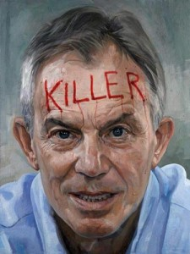“Lead me into war!”
ZBIGNIEW BRZEZINSKI: Blair is a lightweight. I don’t like his political morals and how he’s been enriching himself since leaving office. He preaches high moral language but … I have a visceral contempt for Blair. Not dislike. Just contempt.
GEORGE W. BUSH: Yeah, Blair, what are you doin’?
TONY BLAIR (groveling at the feet of his Master) : Lead me into war…you know I believe in you!
GEORGE W. BUSH (maniacally) : We will rid the world of evildoers!
♣
LASHA DARKMOON: Over a hundred co-conspirators have so far been accused of having been deeply implicated in 9-11, but undoubtedly there are many others whose complicity and silence have had to be bought by the only two means available: the carrot and the stick. The stick involves either the threat of blackmail or instant death if they dare to step out of line — as in the case of Senator Wellstone and Dr David Kelly. The carrot involves bribery and sweeteners: astronomical sums of money paid into secret bank accounts for the rest of their lives, guaranteeing total silence in anticipation of those enormous annual deposits.
Where will the money come from to pay out such stupendous sums?
Quite simple. The money was already stolen before 9/11 with the help of Israeli dual citizen, Rabbi Dov Zakheim. He somehow managed to “lose” at least $2.3 trillion, or $3 trillion according to most other accounts. Antiwar activist and CIA whistleblower Susan Lindauer has given evidence that the money actually stolen from the American taxpayer amounts to a staggering $9.1 trillion.
To get through even $1 trillion wouldn’t be easy. A trillion dollars would be enough to keep 1000 conspirators and their families in pig heaven for the rest of their lives. The other trillions have reportedly made their way into secret bank accounts, with the bulk ending up in Tel Aviv and Zurich.
See here for more on the missing trillions
KEVIN BARRETT: So what happened to the Pentagon’s missing 2.3 trillion dollars—or $9.1 trillion if you believe Susan Lindauer? The one thing we know for sure is that it has never been found. At least not officially. Lindauer says insiders know it was embezzled by agents of Israel. Interestingly, the Comptroller of the Pentagon—the man who was running the Pentagon’s finances—was a known Israeli agent, Rabbi Dov Zakheim.
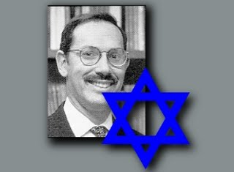RABBI DOV ZAKHEIM
How did a Jewish rabbi gain control over Pentagon finances and manage to lose $3 trillion in three months?
LASHA DARKMOON: Rabbi Dov Zakheim (pictured), born 1948, dual American-Israeli citizen, was appointed Comptroller of the Pentagon in May 2001. This put him in full charge of Pentagon finances. By September 2001, a mere three months later, he had managed to “lose” or misplace three trillion dollars — at the phenomenal rate of a trillion dollars a month.
That’s $1000 billion (or $1 million million) in 30 days! No one in recorded history has ever managed to “lose” such a colossal sum of money in so short a time.
In spite of this, the woefully incompetent — or shamelessly rapacious — rabbi was allowed to continue in his post of Pentagon Comptroller until March 2004, almost another three years. With complete impunity.
Let me give you a few fascinating statistics now that will allow you to view this vast hemmorhage of wealth in its proper perspective. The richest top ten Jewish American billionnaires in 2012, according to Forbesmagazine, owned assets between them amounting to $203 billion. (Seehere). This is roughly one-fifteenth of the $3 trillion Rabbi Zakheim clawed away from the American taxpayer in three months.
The combined wealth of all the billionaires in the entire world in 2012 amounted to $4.6 trillion. (See here). If Rabbi Zakheim actually stole $9.1 trillion, as alleged by CIA whistleblower Susan Lindauer, he would have gotten away with almost twice the total wealth of all the billionnaires in the world.
The missing trillions have reportedly found their way to Israel, resulting since 2001 in vast real estate acquisitions by Israeli interests in South America, Europe, the United States and other parts of the world. Much of the world’s surface today is probably owned by absentee Jewish landlords, with vast holdings under the stewardship of the Rothschild family.
KEVIN BARRETT: The 9/11 attack on the Pentagon targeted the accountants who were on the trail of the missing trillions.
LASHA DARKMOON: How convenient. The crime can no longer be investigated because the investigators have been killed. And the relevant documents were destroyed. Accidentally.
PRESIDENT JIMMY CARTER (sadly): The post-9/11 USA is no longer a beacon of human rights.
GEORGE W. BUSH: Either you are with us, or you are with the terrorists! We will find those who did this! We will smoke them out of their holes! We’ll get them running! We’ll bring them to justice! We will not tire, we will not falter, we will not fail! We will rid the world of evildoers!
SENATOR ORRIN HATCH: We’re going to find out who did this and we’re going after the bastards!
JERRY FALWELL (late televangelist) : I really believe that the pagans and the abortionists and the feminists and the gays and the lesbians—I point the finger in their face and say — ‘You helped this happen!’
BAPTIST PASTOR FRED PHELPS: Thank God for 9/11! Thank God that five years ago the wrath of God was poured out on this evil nation—America, land of the Sodomite damned! The deadly events of 9/11 were direct outpourings of divine retribution, the immediate visitation of God’s wrath and vengeance and punishment for America’s horrendous sodomite sins!
LASHA DARKMOON (aside) : Watch out, Obama!
PAUL CRAIG ROBERTS: If Muslims were capable of pulling off 9/11, they are certainly capable of assassinating Rumsfeld, Wolfowitz, Perle, Libby, Condi Rice, Kristol, Bolton, Goldberg, and scores of others during the same hour of the day. The argument is not believable that a government that was incapable of preventing 9/11 is so all-knowing that it can prevent assassination of unprotected neocons. Try to imagine the propaganda value of terrorists wiping out the neoconservatives in one fell swoop, followed by an announcement that every member of the federal government down to the lowest GS, every member of the House and Senate, and every governor was next in line to be bumped off.
LASHA DARKMOON: Excellent point. If Al Qaeda were so fiendishly clever and formidable that that it could carry out 9/11 so easily, how come it hasn’t assassinated George Bush, Tony Blair, Cheney, Rumsfeld, Wolfowitz, Perle, and all its other implacable enemies? President Bush, would you like to sum up for the 9/11 orthodoxy?
PRESIDENT GEORGE W BUSH: You can fool some of the people all the time, and those are the ones you want to concentrate on.
LASHA DARKMOON: Perfect! A final question. When you were president, were you ever in control? Or were you just a puppet of the Jews?
ARIEL SHARON (from the Other Side) : I want to tell you something very clear. We, the Jewish people, control America, and the Americans know it!
BENJAMIN NETANYAHU (sneering contemptuously) : America is a thing you can move very easily, move it in the right direction…. Once we squeeze all we can out of the United States, it can dry up and blow away.
ADMIRAL THOMAS MOORER (Chairman of the US Joint Chiefs of Staff under Ronald Reagan) : I’ve never seen a President stand up to them. It just boggles the mind. They always get what they want. The Israelis know what is going on all the time. If the American people understood what a grip those people have got on our government, they would rise up in arms. Our citizens certainly don’t have any idea what goes on.
LASHA DARKMOON: Monsieur Voltaire, you have remained remarkably silent all this time … almost as if you were the ghost at the banquet. As one of the world’s most distinguished Enlightenment philosophers, perhaps you would like to give us your views on the Jewish Question. Whither Jewry?
VOLTAIRE (choking with rage) : Our masters and our enemies!… whom we detest!… the most abominable people in the world!… They are, all of them, born with a raging fanaticism in their hearts, just as the Bretons and the Germans are born with blond hair. I would not be in the least bit surprised if these people would not some day become deadly to the human race.

5. Conclusion
LASHA DARKMOON: Forbes magazine, which supplies us regularly with lists of the richest people in the world, makes a point of excluding the very richest: those whose wealth is either beyond computation or public scrutiny. These include the Queen of the Netherlands (the world’s richest woman), the Queen of England, the Queen of Denmark, the Queen of Spain, the Sultan of Brunei, King Fahd of Saudi Arabia, and the kings of Kuwait, Oman, Qatar and Bahrain.
Though the wealth of these few individuals, all of them non-Jewish, is enough to feed the starving planet, it is a mere fraction of the wealth of the Jews.
Most of the world’s wealth is concentrated in the hands of the House of Rothschild, with lesser but still vast (undisclosed) amounts in the secret vaults of a few elite Jewish families: the Schiffs, the Wallenbergs, the Oppenheimers, the Morgenthaus, the Goldman-Sachs, the Lehmans and the Guggenheims. The entire wealth of the world has been estimated as $990 trillion. Of this, the lion’s share, roughly $500 trillion, is reported to belong to one dynastic family alone: the Rothschilds.
The Rothschilds and the Rockefellers (the latter family rumored to be worth $100 trillion) own between them all the world’s major banks, big corporations, conglomerates and oil companies, apart from huge real estate holdings such as castles, palaces, stately mansions, luxury hotels, race courses, casinos, exotic holiday resorts, and vast tracts of farm land and virgin forest.
Staggering amounts of gold bullion, diamonds, jewelry, rare art, antiquarian books, coins, precious metals and stones clog up their underground vaults. These people have never sight eyes on most of the things they possess. They have never set foot on the land they own. In spite of all their fantastic wealth, they feel desperately poor and insecure; nor can they rest easy in their beds until they own everything — and the rest of mankind is reduced to a condition of abject slavery.
9/11 was a catalyzing event for these emperors of opulence. It ushered in a new world order and precipitated a series of catastrophic new wars that would help to create new starving refugees, new impoverished immigrants, and new opportunities for endless exploitation by an essentially hostile Jewish elite.
KEVIN MACDONALD: A new Jewish elite has seized all of the major choke points of American society: academia, the courts, and politics. It’s a hostile elite — hostile to the traditional people and culture of America.
LASHA DARKMOON: In 2000 the 70-year-old Sir Evelyn de Rothschild married affluent businesswoman Lynn Forrester (pictured here). They spent their wedding night at the White House in Washington DC, with Bill Clinton scuttling around serving them drinks and hors d’oeuvres. A year later, on September 11, 2001, the couple hired out the entire top two floors of a 5-star hotel in Manhattan. The hotel had a majestic view of New York.
At 9 am precisely on that fateful morning, September 11, 2001, the lucky couple stepped out onto their balcony where breakfast was served. They had ringside seats of the World Trade Center. They could see the Twin Towers glittering in the distance. They could see the first plane approaching through an azure blue sky … and then the fireworks … the explosions … the billowing smoke … and then the second plane approaching …. They could see men and women leaping from the towers … spiraling downward to their deaths on the concrete below.
As they sipped their coffees on the sunny balcony, musing on life and death and sex and shopping, they had the best seats in the house.
KEVIN MACDONALD (summing up) : It all boils down to this. Today’s Jewish elite hates the nation it rules.
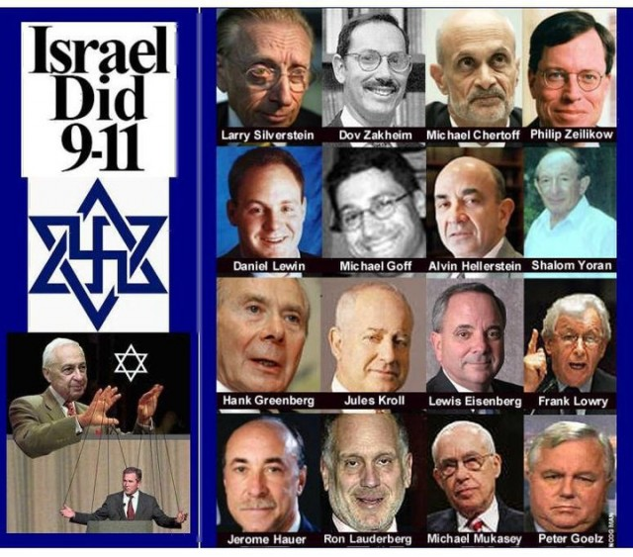
“I WOULD NOT BE IN THE LEAST BIT SURPRISED IF THESE PEOPLE
WOULD NOT SOME DAY BECOME DEADLY TO THE HUMAN RACE.”
— Voltaire, 1771

LASHA DARKMOON
Dr Lasha Darkmoon is an academic with higher degrees in Classics. She is also a poet and translator. Many of her articles have been published here and here; her poems and translations can found on this website.

200 thoughts on “9/11: The Shocking Truth Laid Bare” (Comments)

